**Practice Problems and answers**

**Synthetic aperture radar:**

A aircraft travels in a straight line at a height 0f 10,000m and performs a vigilance survey of a territory parallel to the track (See the diagrams shown in Fig. 1 and 2). The speed is 100ms-1. The radar operates at 10 GHz and its antenna makes an angle of 450 from the nadir (direction directly down). The beam widths Δθ and Δϕ are equal 60.

1. Calculate ‘Swath’ (width of the land strip under surveillance)
2. How many range bins shall be accommodated if the transmission pulse width is 0.25µs?
3. If the air craft collects the data for the period of 300ms, what is the angular resolution (in azimuth or within Δφ )

(d) Considering computations in (b) and (c) what is the typical size of the ‘resolution module’ in the Swath area. See the diagram in Fig2. Illustrate by drawing the grid and mention approximate dimensions.

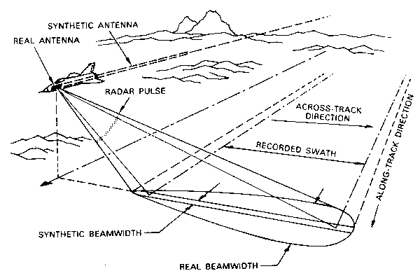 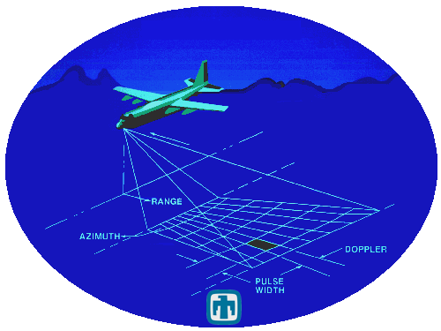

**Δφ**

**Δθ**

**θ**

Fig.1 Fig 2.

**Answer:**

1. Calculate ‘Swath’ (width of the land strip under surveillance)

10,000(tan 470-tan 430)= 10723.68-9325.15 = 1398.5 m ~(1.4 km)

If BW are 80: 10,000(tan 490-tan 410) = 2.81 km

If BW are 160, 10,000(tan 530-tan 470) = 5.734 km.

1. How many range bins shall be accommodated if the transmission pulse width is 0.25µs?

The distance on which range bins are available is calculated as

No of range bins = (989.52)/ 37.5= 26.38



We can say that 26 (or 27) range bins are present

Fig 3

(c) If the air craft collects the data for the period of 300ms, what is the angular resolution (in azimuth or within Δφ )

The aircraft travels 30m in 300ms (=100ms-1 X 0.3s)

This will make the beam width of the “synthetic aperture”



Hence, angular resolution = 0.07 deg

(d) Considering computations in (b) and (c) what is the typical size of the ‘resolution module’ in the Swath area. See the diagram in Fig2. Illustrate by drawing the grid and mention approximate dimensions

Now we calculate the size on the land surface. The resolution grid is as shown in Fig 4, which shows the land footprint in Fig.2.



17.27

17.9

54.98

51.27

53.03

16.7

Fig 4.

From (b) we know that the range bins in the radial direction is 37.7m. Its projection on the horizontal plane will be

in the near region will be (37.5/ Sin 43= 54.98m)

in the central region(37.5/ Sin 45= 53.03m)

in the far region (37.5/Sin 47= 51.27m)

These are the dimensions in the transverse direction.

------------------------------------------------------------------------------

From C we have the dimensions as follows: 0.07 deg= **0.0012217 radian**

Hence in the near region, we have (10,000/Cos 43)X 0.0012217= 16.7m

In the central region (10,000/Cos 45)X 0.0012217= 17.27m

In the far region (10,000/Cos 47)X 0.0012217= 17.91m

These sectioning of the region is in the direction of the flight

---------------------------------------------------------------------------------

**Additional Information/ Technique: (Not for the Exam)**

(The resolution area demarcated by the by the angular resolution are referred as rows)

We see that, in a given row, the area is sliced using the time of arrival, resolved by the transmission pulse width.

**However, The synthetic aperture needs to distinguish the echoes from the different rows**

The echoes from these rows are resolved by one of the two techniques.

(i) By Doppler frequency:

(This approach assumes that there are no fast moving targets in the surveillance region. Mainly used in remote sensing of land masses/ satellite remote sensing)

The row exactly perpendicular to the aircraft motion shall offer 0 Hz as Doppler shift.

The next row shall have radial velocity of 0.12217ms-1(=100 X Sin 0.070) and

The 2nd next shall have radial velocity of 0.24437ms-1(=100 X Sin 0.140) and so on...

The Doppler frequencies will be 8.14 Hz, 16.28 Hz and so on.

The system observes the echoes for 300ms. Therefore the frequency resolution is 3Hz.

Therefore, it is possible to distinguish the echoes from different rows on the basis of the Doppler frequency.

(ii) The Processor processes the echoes from one row (which is perpendicular to the flight line). Then it selects time echoes corresponding to the next row and process. The selection of the echoes is done in the sliding window manner. Fig 5.

Fig.5

Another diagram for better understanding

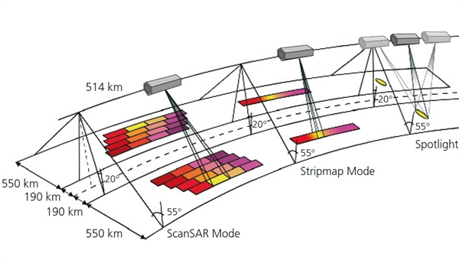

Fig. 6

**Beam steering with phased array antenna**

A two dimensional array of the antenna is set up on X-Y plane. This array has 81 elements (arranged in 9X9 formation). All the elements are located on the grid of 1 unit. This means that the individual element locations are (0,0), (0,1), (1,1) etc and fills up all the locations (i,j) where -4< i, j <+4. The wavelength of the transmission is 2 units.

(a) When the beam is pointing at zenith (in the direction of +ve Z axis), what is the beam width of the antenna beam in X-Z plane and in Y-Z plane?

(b) In order to tilt the beam at -100 with respect to positive ‘Z’ axis (making angle of 800 with positive x axis) in X-Z plane, what will be the phase difference between the antenna element at (0,0) and (1,0)? (Mention leading of lagging)

(c) For the beam tilt in (b), calculate the phase difference between (0,0) and (2,2).

(d) Now, consider a requirement of tilting the beam by 300 in azimuth and 600 degree in elevation. Find out the general equation for the phase shift between (0,0) and (i,j)

*(Fig.6 shows the position of the beam directions. P(b) is the direction in (b) and P(d) is the direction in (c))*

Z

Y

P(d)

P(b)

600

100

300

X

**Answers:**

(a) When the beam is pointing at zenith (in the direction of +ve Z axis), What is the beam width of the antenna beam in X-Z plane and in Y-Z plane?

The antenna dimensions are 9λX 9λ. Hence the beam widths are 7.770 (70/9) in both X-Z and Y_Z planes.

(b) In order to tilt the beam at -100 with respect to positive ‘Z’ axis (making angle of 800 with positive x axis) in X-Z plane, what will be the phase difference between the antenna element at (0,0) and (1,0)?

If the beam is tilted in X-Z plane, the situation is equivalent to ‘One-Dimensional beam-steering”

The phase shift between adjacent elements (in degrees)

= (dX Sin 100)/λ X360= 1X 0.173648/2 X360 = 31.25660

The phase of the element at (1,0) will be delayed (or lagging) with respect to phase of element (0,0). In other words, if the signal at (0,0) is ‘Sin(ωt)’ then the signal at (1,0) will be “Sin(ωt-31.25660).

(c) For the beam tilt in (b), calculate the phase difference between (0,0) and (2,2).

This case of beam tilt in X-Z plane, the elements in one column (parallel to Y axis) will have the same phase shift. Hence all the elements with second parameter 2 will have the phase shift of 61.51330 (31.2566X2).

(d) Now, consider a requirement of tilting the beam by 300 in azimuth and 600 degree in elevation. Find out the general equation for the phase shift between (0,0) and (i,j). Compute the phase difference value for (3,4)

For generalized case, the path difference is given by scalar product between the position vector and the unit vector in the direction of the beam.

Hence the phase difference = (path difference)/ λX 360.

Hence we have



=-413.820 = OR -53.820

**Antenna****Pattern shaping with linear phased array antenna**

A linear array of 11 elements placed along ‘X-axis’. The elements are separated by 1 unit and having location co-ordinates of (-7,0), (-6,0) .... up to (+7,0).

Assumption:

1. The radiation pattern (as a function of Sin θ) is Fourier Transform of Aperture intensity pattern)

2. All elements are assumed to have omni-directional pattern, OR radiation pattern of individual element is omni-directional).

(a) Equal amplitude and phase signals are fed to all the elements. Describe the radiation pattern in X-Z plane. In other words, radiated signal amplitude with respect to angle (define angle measurement with sign convention)

**Answers:**

(a) Equal amplitude and phase signals are fed to all the elements. Describe the radiation pattern in X-Z plane from angle 0 to 1800 according to Cartesian convention. In other words, derive the expression of radiated field with respect to the elevation angle. The wavelength of the signal is 2 units.

Equal amplitude feed to the antenna pattern can be considered as a rectangular function.

Hence, the radiation pattern will be ‘Sinc’ function (Sin x/ x).

Where x= (ndπ Sinθ/λ);‘d’ is inter-element spacing, ‘n’ is no. of elements and angle θ is measured from the zenith or the direction perpendicular to the array axis.

For a large array or small values of θ we can replace Sinθ by θ.

==================================================================

Confirmation and related information:

When target located at angle θ (measured from the zenith), receives signals which is vector sum of signals from individual elements. We know that these signals are progressively phase shifted by Δϕ=(d Sin θ/ λ X3600).

The resultant of these signal be zero when Δϕ = 360/n; where, n= no of elements.

 🡺substituting this value we get x=π and Sinc(x)=0

==================================================================

For this antenna array, in X-Z plane will be given by

Sinc(5.5πXSinθ).

Here, θ is zero for +ve Z axis. It is measured +ve clockwise.

However, If Cartesian conventions is used, the expression becomes ‘Sinc(5.5πXSinθ-π/2)’

(3) A Doppler weather radar operates at of 2 3 GHz with a pulse width μs. It transmits a conical beam in horizontal plane and rotating in Azimuth. The beam-width is 10°(=Δθ=Δφ)Υ in both azimuth and elevation. Compute the radar cross section (σ) of distributed air target at a range of 15 km. The volume reflectivity of = 10-16.m2.m-3 at 3GHz.

300mm

R

Mean Dia of the beam= RΔθ=RΔφ

At any instance, the radar pulse occupies the volume shown by pale blue. The shape is a frustum of a cone, and it’s volume is given by🡪(cτ/2) X (πRΔθ XRΔφ)/4= (300) X π X(15X103)2X{10X(π/180)}2=

≈ 6.46 X 109 m2=

Radar cross section = 6.46 X 109X 10-16= 6.46 X 10-7m2.